# watsonx Orchestrate Lab 1b:

# Building A Custom Skill

Objective

Sometimes, the out of the box skills might not be enough to achieve what you want to do. Or, your organization may have a custom tool, function, which you wish to incorporate into a workflow. In this lab, you will learn how to set up a custom skill using a custom-made Open API Script. The Open API specifications are connected to two agents – “Get Historic Sales” and “Calculate Reorder Quantity” which we’ve created using a python code using watsonx.ai and crew.ai in the backend.

Use Case:

In this lab, you will learn how to configure custom skills for text2sql to retrieve historical sales and quantity data.

The high-level steps to accomplish this are as follows:

1. Create a new Skill using the custom Open API specification.

2. Enhance and Publish the Skill.

3. Add your custom skill to Skill Catalog.

4. Connect the Apps to Skill Sets

5. Add Skills to AI Chat

6. Test the Skills.

## Configure Custom Skills

1. Go to Skill Studio from the top left hamburger menu

1. Create a new skill by using the option “Import API”

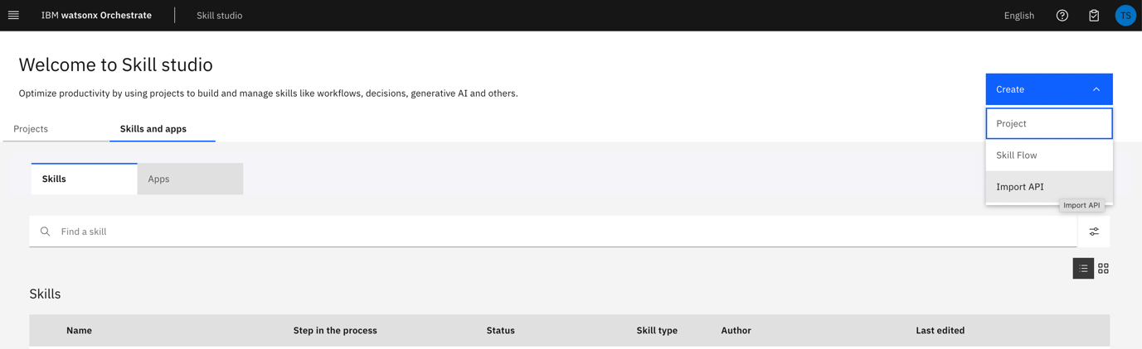

1. Download the Open API specification for [Text2SQL](https://github.ibm.com/Tannavi-Snehal/Agentic-AI/blob/main/text2sql_crewai/text2sql_openapi.json) and then import the file.

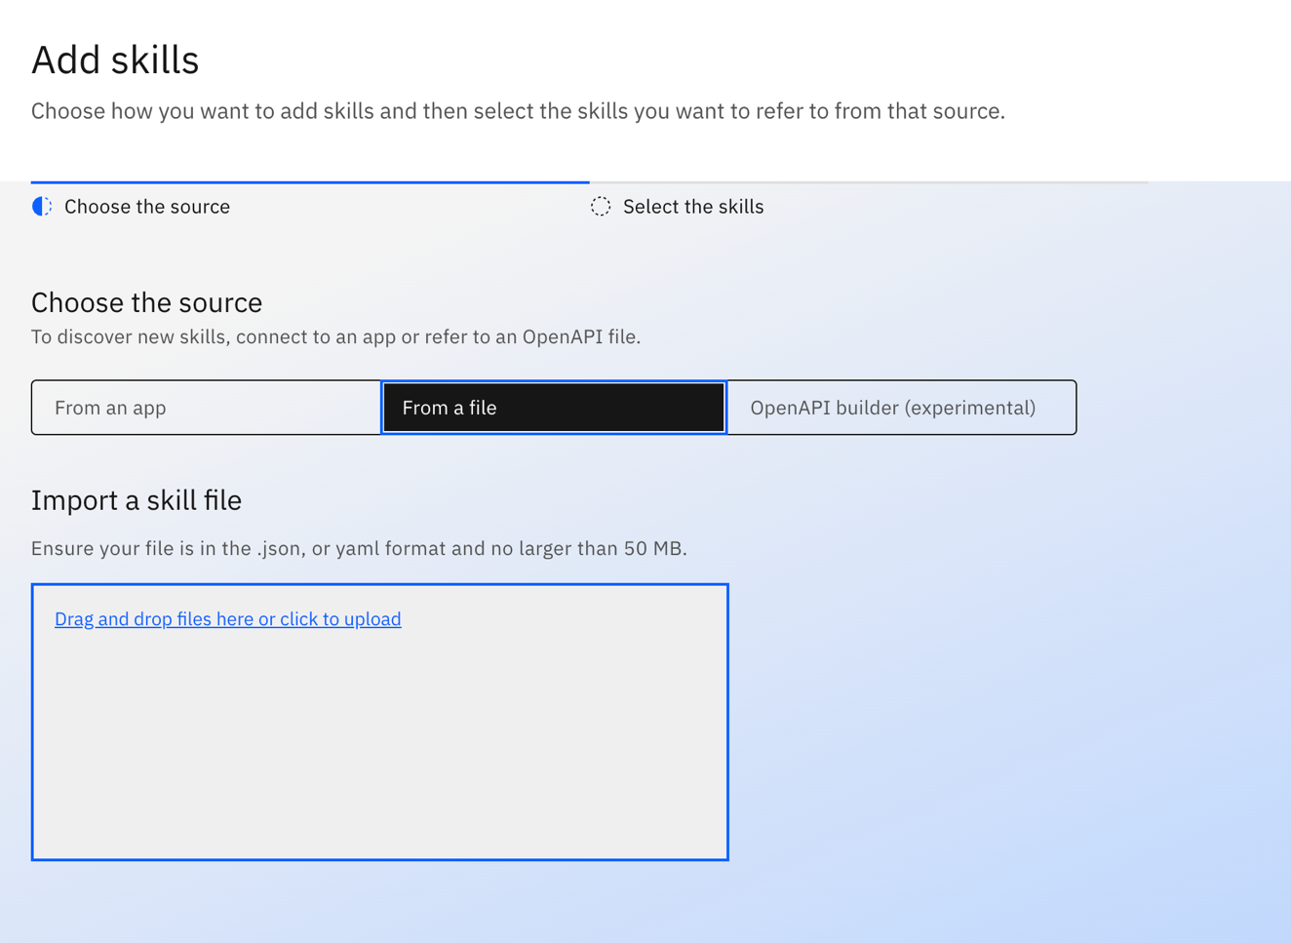

1. Select the Skill “Text2SQL with Crew AI” and Add.

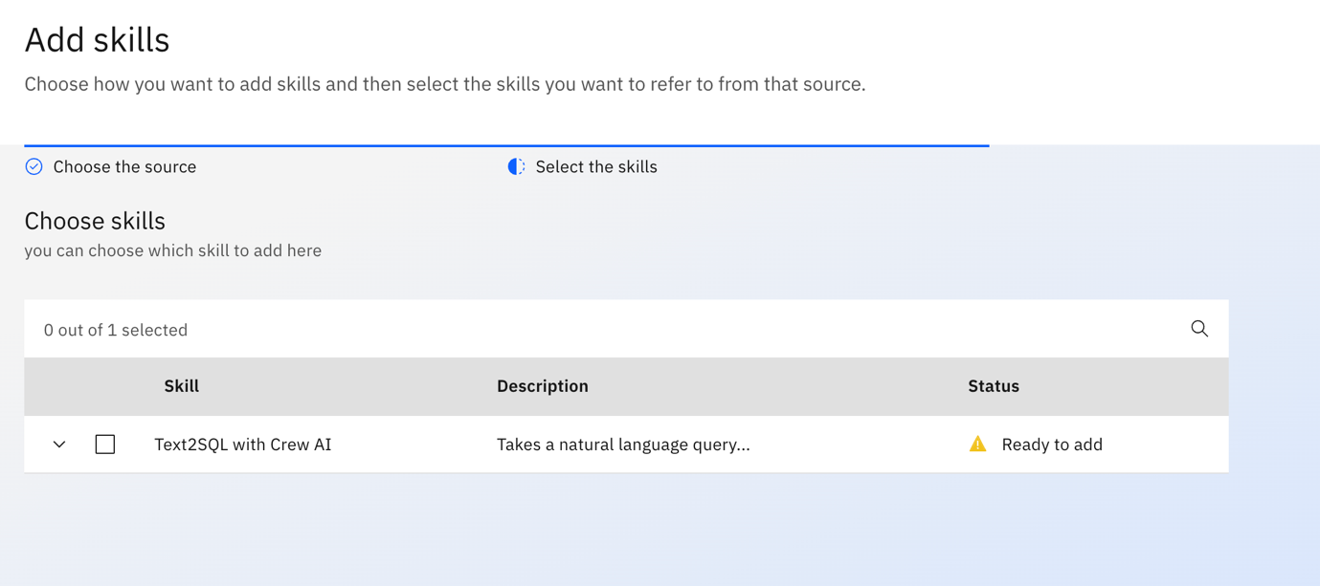

1. Click on the menu of this skill once it has been imported successfully and then select “Enhance this Skill”.

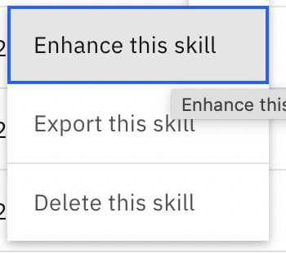

1. Publish the Skill by clicking the “Publish” button.

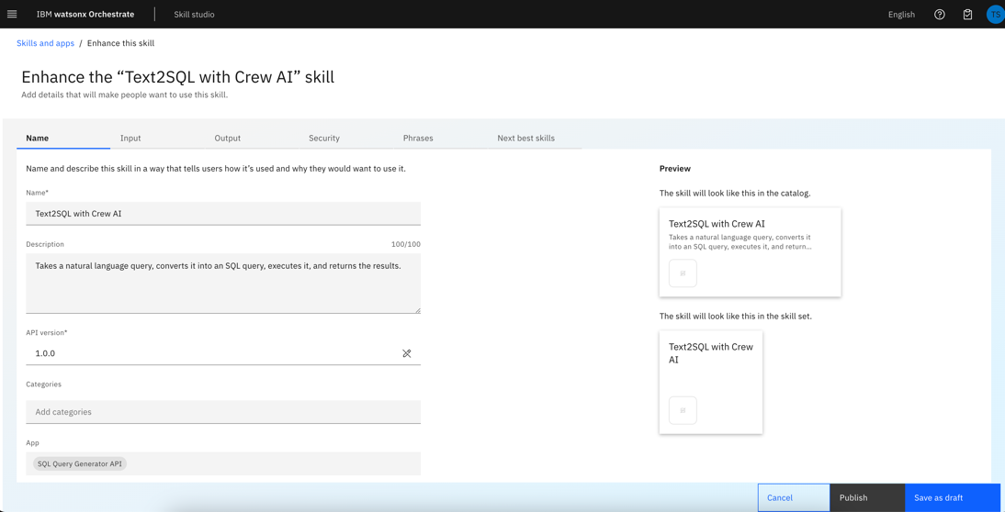

1. Go to Skill Catalog and search for “Get Historic Sales” and select the App.

1. Add the “Text2SQL with Crew AI” skill by clicking on the “Add Skill” button.

1. Connect the app by clicking on “Connect App” button and provide the following credentials:

username: test

password: test

And then click on “Update App”/ “Connect App”.

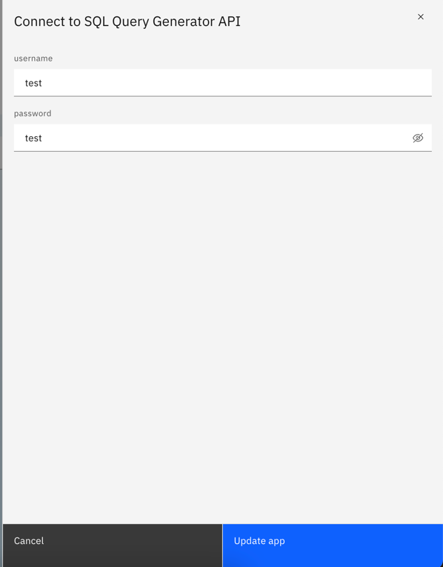

1. Follow the same steps (Steps 1 to 6) to configure [Calculate Reorder Quantity](https://github.ibm.com/Tannavi-Snehal/Agentic-AI/blob/main/calculate_reorder_quantity/calculate_reorder_quantity_openapi.json) skill.
2. In the Skill Catalog, search for “Calculate Reorder Quantity” and select the App.

1. Add the “Optimal Reorder Quantity” Skill.

1. Connect the application using the credentials mentioned in Step 7.

## Configure AI Agent with Custom Skill

Note:

Up until 12 March 2025, only admins can configure AI agents within a tenant.

Only proceed if you have admin access.

1. Go to “Skill Sets” from the top left hamburger menu.

1. From the dropdown menu select “Orchestrate Agent Skillset”

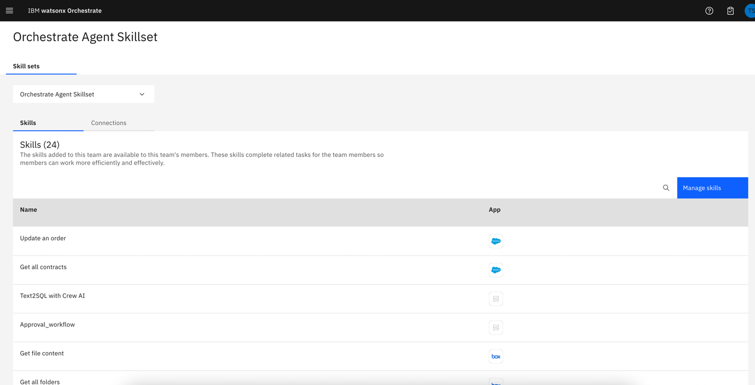

1. Move to the Connections tab and search for “Get Historic Sales” and Edit the connection.

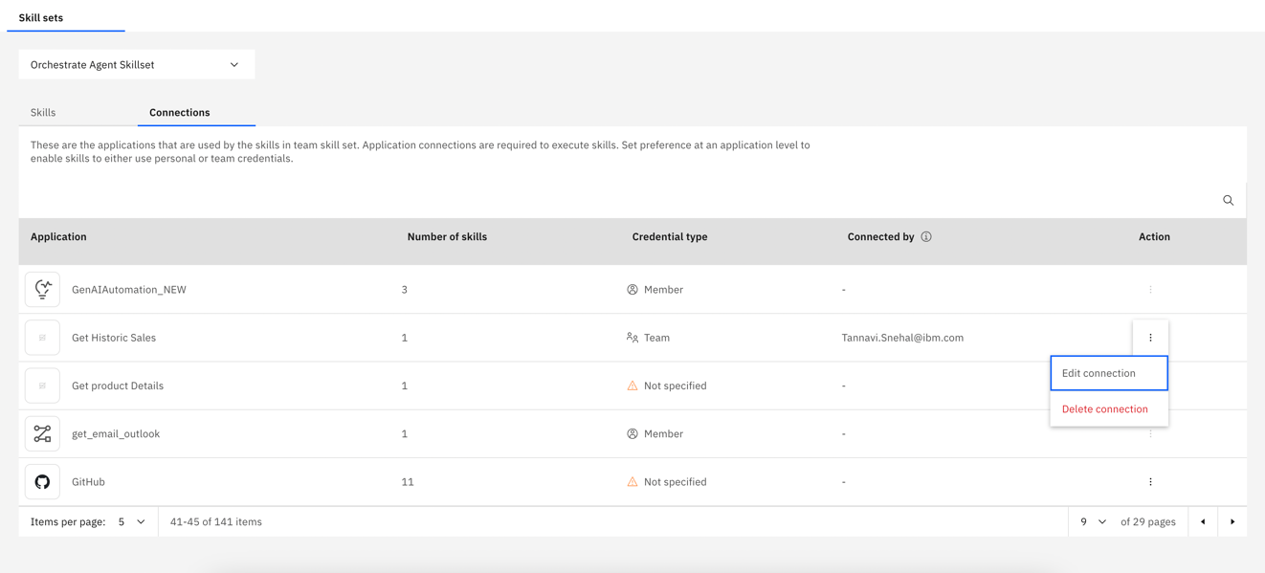

1. Connect the app by clicking on “Connect App” button and provide the following credentials:

username: test

password: test

1. Once successfully connected, move to the AI Agent Configuration from the top left hamburger and move to Apps and Skills.

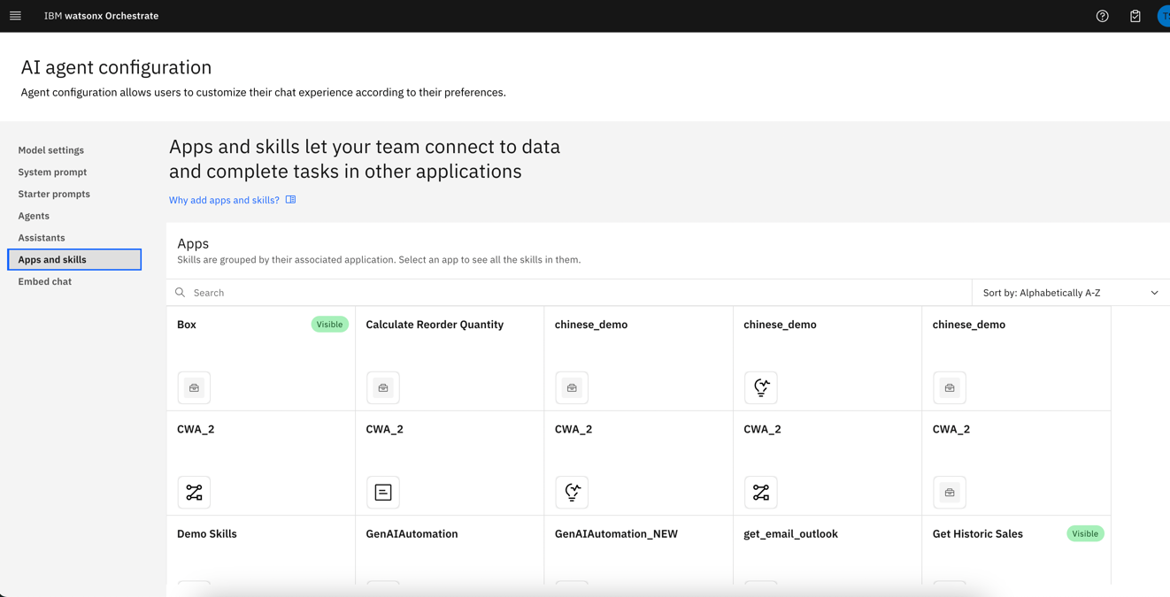

1. Search for “Get Historic Sales” and add the “Text to SQL with CrewAI” skill to AI Chat.

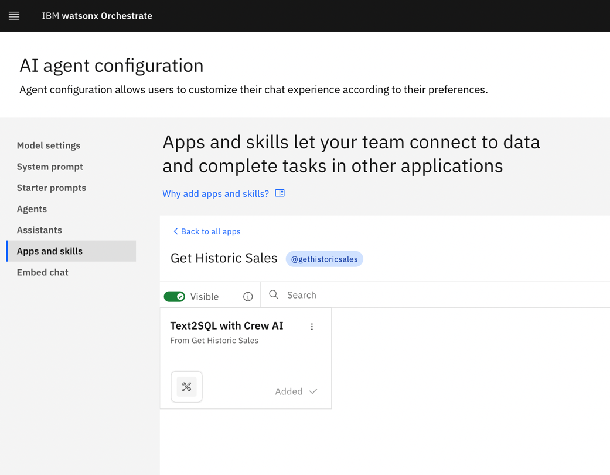

1. Go back to all aps and Search for “Calculate Reorder Quantity” and add the “Optimal Reorder Quantity” skill to AI Chat.

## Test custom skills

Go to Chat window from top left hamburger menu and try the following queries:

1. @gethistoricsales What is the sales figure for Xtralife for the last 3 months?

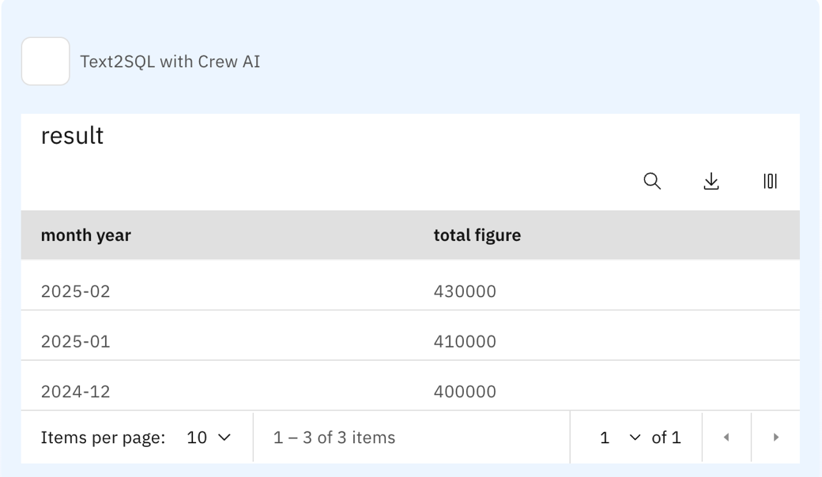

1. @gethistoricsales What is the quantity sold last year this month for Xtralife?

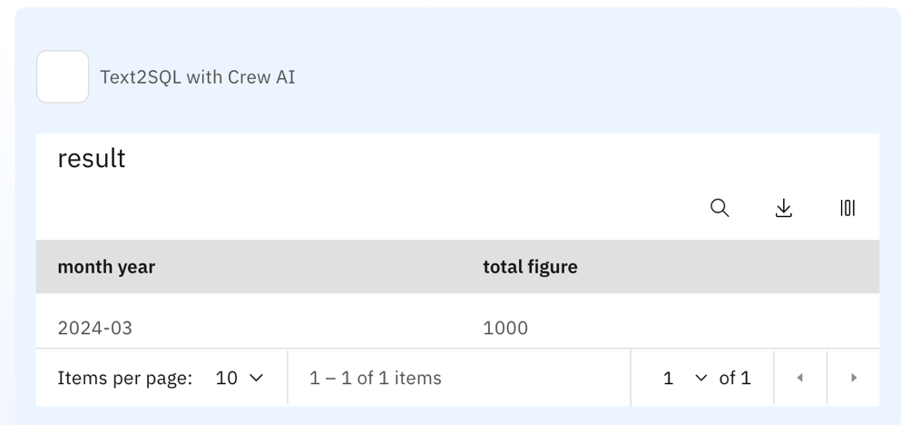

1. @calculatereorderquantity What should be the optimal reorder quantity if my current inventory has 1000 units, last month sales was 3400 units and forecast for the next month is 3107 units?

